1. **Download student assignment**
   1. Go to T-Square > CS 1371 > Assignments
   2. To the right of the assignment you want to grade, click the number under the “In/New” column (e.g., 886/886).
   3. You should be able to see all students in the class—not just your section. If you can’t, contact one of the STAs to get T-Square access.
   4. Click the Download All link in the top right.
   5. Check the following boxes: “Student submission attachment(s), Grade file, Feedback Attachment(s)” (you can just select all, but it’ll be way slower). Click the “Download all link” that appears.
2. **Setup the autograder**
   1. Unzip the bulk_download.zip. Rename the extracted folder something that makes sense (e.g., ‘Homework 2’).
   2. Add in all the grader files
      1. *Solutions -* In the directory that contains all the student folders, create a folder called “Solutions.” Copy all the solution .m files from the Homework Team dropbox into this directory. Make sure there is one solution file for each problem, including the ABCs file.
      2. *Copy Files -* In the directory that contains all the student folders, create a folder called “Copy Files.” Each file contained in this directory will be copied into each student’s Submission attachment(s) folder. Put all the Copy Files for that homework from the dropbox into the Copy Files directory you made. Go ahead and make the directory even if you aren’t putting anything there.
      3. *Rubric -* Copy the rubric file (e.g., hw04_rubrica.txt) into the directory that contains all the student folders.
      4. *Grader Files -* Copy all the grader files into the directory that contains all the student folders. There’s like 20 files.
   3. If (when) something goes wrong and everything’s only half graded, you might need to start grading over. *Before you start grading, make a copy of the entire homework folder with everything in it (e.g., Homework 2).* Call it Homework 2 backup or something.
   4. *Any time you make corrections to the rubric or solution files, make sure you update them in your backup folder* ***and the homework team dropbox****.*
3. **Run the autograder**
   1. The main grader file is called MINOS. Go to the Homework directory in MATLAB (with all the student folders) and call it as: MINOS(true, true, true). The grader will ask if you want to run the setup. Press “No” and enter the rubric name as a MATLAB string (e.g., ‘hw01_rubrica.txt’ – make sure you include the single quotes!)
      1. Input argument 1: Parse (removes invalid characters from student submissions and prevents infinite while loops)
      2. Input argument 2: Copy (copies everything from Copy Files into each student’s submission)
      3. Input argument 3: Delete (deletes all the student attachments after grading)
   2. When everything works, note the class averages if you want to send it in the announcement. These are out of 100 and don’t include zeros. The last one is the overall score. Averages.txt has everything ready to copy/paste into the announcement.
   3. Type “Y” at the prompt to delete submission files. This is super important or it’ll take forever to upload.
4. **Upload everything to T-Square**
   1. Delete everything except for the student folders and grades.csv file from the homework folder. This includes the Solutions folder, Copy Files folder, and all grader files/rubrics. *If you miss deleting a file, you’ll get a “Invalid zip format” error when uploading to T-Square.*
   2. Zip the Homework folder up. This shouldn’t include anything but the student folders and grades.csv.
   3. Go back to the assignment on T-Square and select “Upload All”

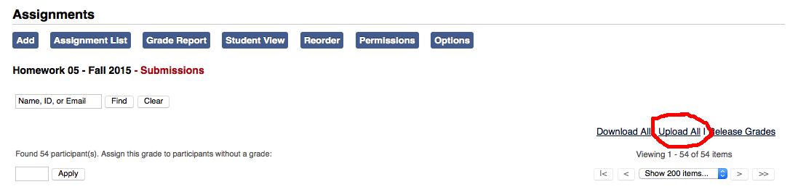

* 1. Select the zip folder and choose to upload “Grade file” and “Feedback Attachment(s).” You probably want to select “Release now”—if you don’t, you can manually release them later. Press upload.
  2. Go get a snack or something—this part takes forever. When it finishes, you’ll get one of two messages:
     1. “Zip folder in incorrect format”: check to make sure that you deleted everything from the zip folder except the student folders and the grade.csv.
     2. “Connection to the server timed out,” “Service temporarily unavailable” (or something like that): this usually means it actually worked. Go back to the assignments and go to the last student alphabetically to make sure it uploaded for everyone.
  3. Add the announcement. Just copy/paste a previous announcement, and change the assignment average, resubmission due date, and add a “Go Jackets” if it’s Fall semester and a game weekend :)